Writing Lesson No. 1

Teaching of Literacy Skills

Topic 1: Concept of Literacy
What is literacy?
The term literacy refers:
1.
often mainly to reading,
2.
sometimes to reading and writing,
3.
and rarely, to reading, writing, speaking and listening

The activities of reading, writing, speaking and listening in a learning environment are included in literacy.
The National Literacy Trust defines:
“We believe literacy is the ability to read, write, speak and
listen well. A literate person is able to communicate effectively with others and to understand
written information.”

As such, these skills are essential components of literacy, and
the active ability to combine these
skills is known as developing or engaging in literacy skills.

These skills are critical in communication. In today’s world,
media and technology are essential components of communication.

For

example, when you use your laptop to obtain information from some website; you are using the literacy skills.

Topic 2: What is Meant by Literacy Skills?

We use the term of Literacy Skills in many contexts: for instance, while reading, while writing, while speaking, etc. We also talk about literacy rate of a country, and compare it with that of the other. So what do we mean by this term? What are the skills related to “Literacy”? Let us try to define it in more detail.
Literacy skills are those which help in:

•
developing literacy, and
•
improving literacy

Each skill contains several sub-skills. For instance: reading. When you are reading a text on the page of a book in front of you
- you pass though unfamiliar words, and search for their meanings to understand the individual words contained in the text
- you connect the words to understand the meaning of the text as a complete set
- these activities help you read and understand the text of the book
- these sub-skills are involved in the “reading” skill

As such the “Reading” skill includes a number of sub-skills, which collectively help in developing “Literacy,” Same is the case with the other skills.
Using literacy skills students gain knowledge though reading as well as using media and technology. These skills also help students create knowledge through writing as well as developing media and technology.

They include even such things as awareness of the sound of language, awareness of print, and relationship between letters and sounds.
All skills that are needed for reading or writing are included in literacy skills.

Topic 3: Different Types of Literacy Skills

There are different types of literacy skills:, e.g.:

- is literacy skill because you had that level of literacy which enabled you to read the sentence. Reading a book, newspaper or thesis etc. is all included in literacy skills.
Reading: even if you read a sentence, it
- like reading the words, understanding
Many sub-skills are involved in the reading skill,
the words, connecting the words, connecting the meaning of those words, and then collectively understand the message.
- a children story book would require
However, there could be different levels as reading
different level of literacy than reading a book of philosophy. There could also be different versions of the same text available for adult reading and for children reading requiring different levels of reading skills.
•
Different levels of skills are also involved in writing a sentence and writing a book.
- Listening requires familiarity with the sounds; because while listening you pick up different sounds, understand them, and connect these sounds with the message for overall understanding. These are all included in literacy skills.
•
Words are also essential part of literacy skills.

Extra Reading

o is but also includes skills like critical thinking,
the ability to read and write,
Literacy

listening, speaking, viewing and presenting.
o
is being at home with numbers,
Numeracy
mathematical problems.

and knowing the smartest way to solve

(Literacy and numeracy are globally ranked in the top three skills that employers look for in an employee).

Topic 4: Learning Literacy Skills

Literacy skills help students gain knowledge through reading as well as using media and technology. These skills also help students create knowledge through writing as well as developing media and technology.
There are two ends to the concept of learning literacy skills.
1.
Students’ concern is to learn these skills
2.
Teachers must ensure that their students learn all the main and the allied s
included in literacy skills.

in a way that allows you to communicate effectively. The power of literacy lies not just in the ability to read and write, but rather in a person’s capacity to apply these skills to effectively connect, interpret and determine the workings of the world in which they live.
ub-skills
Literacy is the ability to read, view, write, design, speak and listen

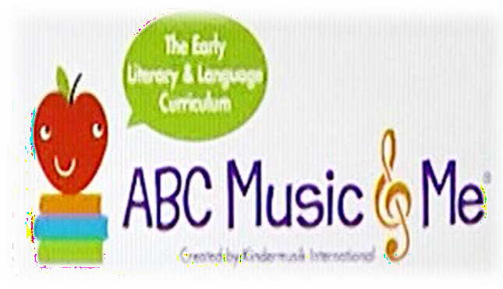
Topic 5: Significance of Literacy Skills

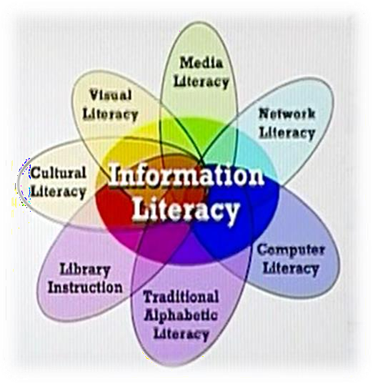
Figure 1 presents a very basic level of literacy – some alphabets, a musical note, some pictures – it is, most likely, connected with very young children who are starting to learn. For them, nevertheless, these are the literacy skills that they have to learn, and proceed to improve forward.
Figure 2
information from web, how to search, save, how to put/ retrieve
computer literacy will require knowledge of
A much more complicated situation is presented by Figure 2. It is a highly developed and advanced model of literacy.
For instance,

Figure 1

technology, writing, typing, reading, how to download

information in/ from mail, etc.

Literacy skills provide the basics to proceed for learning and gaining, and creating knowledge in
any discipline. The level of these skills may be different according to the level of learners.

Extra Reading

If it were up to us, the benefits of reading and writing would be mentioned and celebrated on every broadcast of morning and evening news: "It's 11 o'clock, have you read to your children today?"
children who do not receive daily read-alouds
Here are 5 powerful facts about literacy.
1. Reading aloud is vital.
Research proves that reading aloud to children every day puts them almost a year ahead of

and that is regardless of parents' income, academic or cultural background. On top of that, pediatricians are now prescribing read- alouds alongside their nutrition and health advice in recognition of the proven benefits on brain development and vocabulary acquisition.

2. Literacy saves lives.

According to UNESCO, improvements in women’s education explained half of the reduction in child deaths in the past twenty years.
Mothers who are educated are more likely to have
Imagine what will happen when every child and adult can read, write and learn all they want and need to know.
their children vaccinated, and more likely to send them to school.
3. Literacy teaches you to own and value your own story.
All Global Monitoring report states that there is a clear link between
The Education for

literacy and a positive self-image. Building confidence as a reader, writer, listener and
These core abilities are used every minute of every day to read the world. More than that, reading stories gives a greater understanding of self. Suddenly there are characters who feel the same feelings as you, who share your struggles, your hopes and your dreams.
community of readers and writers.
4. Literacy gets you to the goal.
Studies have shown that people who write down their goals are 80% more likely to achieve
them.
speaker is transformational in a person's life.
Literacy brings us out of isolation and into a

Having documentation of our goals and reading them back to ourselves on a regular basis keeps our motivation at the forefront of our minds and allows us to start to create
Simply having the ability to write down
action plans. This is productive literacy in action.

what you want to do and where you want to go leads to an impressive head-start.
5. Literacy empowers.

The ability to seek out and understand information gives us all independence to make choices, to advocate for ourselves and to learn about our community and world.
can read and write are powerful in society and studies show that literacy leads to greater
People who

self-reliance and civic engagement.

http://www.litworld.org/blog/2014/8/29/5-things-you-need-to-know-about-the-power-of-literacy

Topic 6: Literacy Skills in Classrooms

Supporting
Development of literacy skills is strongly connected to the development of a country.
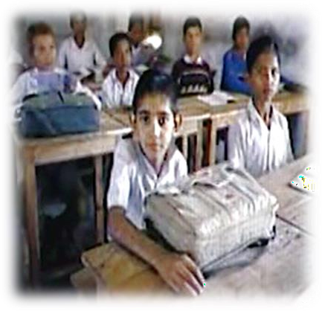
young children’s language and literacy development has long been considered a practice that produces strong readers and writers later in life, who then contribute positively in the country’s development and growth.
which again ultimately contributes to the country’s development and growth.
Literacy skills are also strongly connected to classroom learning,

Figure 3
Figure 3 presents a picture of a classroom that is not using any technology, which is a very important helping factor of the modern classroom. While Figure 4 shows a modern classroom, where each student is using technology and is learning in an interactive manner. Notice that there are no heavy bags in Figure 4.

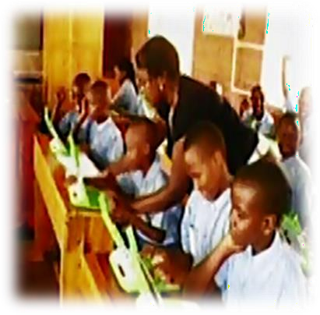
Figure 4

Classrooms help to a great extent in improving literacy skills that provide the base for the development of a country. For instance:
•
•
Literacy rate in USA – 90-95%
Literacy rate in Pakistan – 58%

As such, the literacy skills being used or developed in
the classroom connect with the
development of the country at the macro level.

